#### Arslan Latif

#### Muhammad Tabish Mirza



DEPARTMENT OF COMPUTER SCIENCES

COMSATS UNIVERSIY ISLAMABAD, WAH CAMPUS

PAKISTAN

SESSION 2019-2023

*Undertaken By:*

#### Arslan Latif

REG. NO. CIIT/ SP19-BCS-175/WAH

#### Muhammad Tabish Mirza

REG. NO. CIIT/SP19-BCS-188/WAH

*Supervised By:*

#### Dr. Saleha Masood

A DISSERTATION SUBMITTED AS A PARTIAL FULFILLMENT OF THE REQUIREMENTS FOR THE DEGREE OF BACHELORS IN COMPUTER SCIENCE

DEPARTMENT OF COMPUTER SCIENCES

COMSATS UNIVERSITY ISLAMABAD, WAH CAMPUS

PAKISTAN

SESSION 2019-2023

FINAL APPROVAL

This is to certify that we have read the thesis submitted by **Arslan Latif** having registration no. SP19-BCS-175 and **Muhammad Tabish Mirza** having registration no. SP19-BCS-188. It is our judgment that this thesis is of sufficient standard to warrant its acceptance by the COMSATS University Islamabad, Wah Campus for the Bachelor’s Degree in Computer Science.

#### Committee:

1. Internal Examiner

Mr./Ms ____ ____ ____ ___________ __

Department of Computer Science, COMSATS University Islamabad, Wah Campus.

1. External Examiner

Mr./Ms ________________________ ____ ___

1. Supervisor

__ _________________ ____ ______

Dr. Saleha Masood

Department of Computer Science, COMSATS University Islamabad, Wah Campus.

1. Head of Department

____ __________ ____ ______

Dr. Sheraz Anjum

Department of Computer Science, COMSATS University Islamabad, Wah Campus.

A report submitted to

COMSATS University Islamabad, Wah Campus

As a partial fulfillment of requirements for the award of the degree of Bachelor of Science in Computer Science

DEPARTMENT OF COMPUTER SCIENCE COMSATS UNIVERSITY ISLAMABAD WAH CANTT

# DEDICATION

We dedicate this project to the Almighty Allah who has blessings upon us and with His help we were able to complete our project within stipulated time, thanks to Him for guidance, strength, power of mind, protection and skills and for giving us a healthy life. This project is wholeheartedly dedicated to our beloved parents, who have been our source of inspiration and gave us strength when we thought of giving up, who continually provide their moral, spiritual, emotional and financial support. Also our friends who have motivated us, who have been our support system throughout the journey. Without the support of our Supervisor, Parents and friends we would not able to complete our project.

# ACKNOWLEDGEMENT

All praises to Almighty Allah the most merciful and compassionate, without his help and blessing we would have not been able to complete this project. This project could not have been completed with the help, encouragement and guidance of the following person.

Our respected project supervisor **Dr. Saleha Masood**. She was available for our guidance whenever we consulted her, she always reserves sometime for us though being very busy, whenever we needed any help of any nature from her. Without her help and personal interest, we could never be able to develop such project.

# PROJECT BRIEF

PROJECT NAME ONLINE AUCTION SYSTEM

ORGANIZATION NAME COMSATS UNIVERSITY ISLAMABAD,

WAH CAMPUS

OBJECTIVE TO THE MAIN AIM IS TO DEVELOP AN ONLINE AUCTION SYSTEM WHICH WILL PROVIDE A FORUM FOR SELLERS TO MEET AND INTERACT WITH BUYERS AND SELL ITEMS TO INTERESTED BIDDERS. IT WILL INCLUDE DIFFERENT PROCESSES LIKE DATABASE CREATION, WEBSITE CREATION, DOCUMENTATION, ARCHITECTURAL DESIGN, TESTING ETC.

UNDERTAKEN BY

SUPERVISED BY

* 1. ARSLAN LATIF
  2. MUHAMMAD TABISH MIRZA

DR. SALEHA MASOOD

DEPARTMENT OF COMPUTER SCIENCE COMSATS UNIVERSITY ISMALABAD, WAH CAMPUS

STARTED ON COMPLETED ON COMPUTER USED

MARCH 2022

DEC 2022 LENOVO CORE I5

OPERATING SYSTEM TOOLS USED

MICROSOFT WINDOWS 10

HTML 5, BOOTSTRAP, PHP, MY SQL, CSS3, JAVASCRIPT, LARAVEL 5, AJAX,

VISUAL STUDIO

# ABSTRACT

The main aim is to revamp the previous website of Trust and Democratic Education and Accountability (TDEA). The previous website was merely an instructional website with zero presentation and zero functionality. We intend to organize it and make it more serviceable, where user can apply for job, admin can manage the job applications and employee portal, also an employee portal will be provided where each employee will get updated. Other features include live chat and FAQ’s. It will include different processes like database creation, website creation, documentation, architectural design, testing etc.

The purpose of this document is to provide comprehensive requirements and Goals for revamp of the website. This document helps the reader to visualize the intent of the developers and how they expect the program to run and react to input from the users. This document is the documentation and report of the project that was made during the final year of the degree. It will also include a set of use cases that describe interactions the users will have with the software. Finally, this document will also be referenced during implementation and testing of the final system, to be performed at a later iteration.

**TABLE OF CONTENTS**

TABLE OF CONTENTS

Chapter 01 01

INTRODUCTION 01

* 1. Introduction 02
  2. Purpose of this document 02
  3. Scope of this document 02
  4. Overview 02
  5. Objective of the project 02
  6. Significance of the system 02
  7. Report layout 03

Chapter 02 04

GENERAL DESCRIPTION 04

* 1. General Description 05
     1. Product Functions 05
  2. Similar System Information 05
  3. User Characteristics 05
  4. User Problem Statement 05
  5. User Objectives 05
  6. General Constraints 06

Chapter 03 07

REQUIRNMENT ANALYSIS 07

* 1. Functional Requirement 08
     1. Login/Sign Up 08
     2. Employee Portal 08
     3. Request Job 08
     4. Post Job 09
     5. Select Expertise 09
     6. View Application 09
     7. Live Chat 10
     8. Tender Notice 10
  2. Other non-functional attributes 11
     1. Security 11
     2. Binary Compatibility 11
     3. Reliability 11
     4. Maintainability 11
     5. Portability 11
     6. Extensibility 11
     7. Reusability 11
     8. Application Affinity/Compatibility 11
  3. Interface Requirements 11
     1. User Interfaces 11
     2. Hardware Interfaces 11
     3. Communications Interface 11
     4. Software Interfaces 12
  4. Performance Requirements 12
     1. Response time 12
     2. Cost sensitivity 12

Chapter 04 13

OBJECT ORIENTED DESIGN 13

* 1. Critical Use Case Requirements 14
     1. User Module 14
  2. Use Case Diagrams 14
     1. Class Diagram 16
     2. Activity Diagram 17
     3. Sequence Diagram 19
     4. ERD 22
     5. Preliminary Schedule 23
        1. Preliminary Budget 23

Chapter 05 24

SYSTEM DESIGN 24

* 1. Designing 25
  2. Interface Design 25
  3. GUI 25
     1. Home page 25
     2. About Section 26
        1. About Page 26
     3. Services Section 27
     4. Team Lead Section 27
        1. Mr. Shahid Fiaz (CEO) Profile Page 28
        2. Mr. Mudassir Rizvi (SDP) Profile Page 28
        3. Mr. Amjad Ali Shah (SDO/F) Profile Page 29
        4. Mr. Atta Ur Rehman (DDO) Profile Page 29
     5. Portfolio Section 30
     6. Newsfeed Section 30
     7. FAQ Section 31
     8. Contact Us Section 31
     9. Job Portal 32
        1. Login Page 32
        2. Registration Page 32
        3. Personal Information Section 33
        4. Education Section 33
        5. Experience Section 33
     10. Employee Portal Page 34
         1. Employee Panel 34
            1. Login Page 34
            2. Employee Home Page 35
            3. Employee Profile Page 35
            4. Employee Attendance Page 35
            5. Employee Salary Page 36
            6. Employee Project Page 36
         2. Admin Panel 36
            1. Login Page 36
            2. Admin Home Page 37
            3. Add Employee Page 37
            4. Employee Page 38
            5. Add Employee Attendance Page 39
            6. Add Employee Salary Status Page 39
            7. Add Employee Projects Page 39
            8. Show Job Applicants Page 40
            9. Print Job Applicants List Page 40

5.3.10.3.0. Database 41

* + 1. Live Chat 41
  1. Interface Specification 42
     1. User Interface 42
     2. GUI 42
  2. Code Design 42
  3. Software Interfaces 42
  4. User Friendly 42
  5. Design Constraints 42
     1. Standards Compliance 42
     2. Hardware Limitations 42

Chapter 06 43

QUALITY ASSURANCE 43

* 1. Introduction 44
  2. Testing Levels 44
  3. Testing plane 44
     1. Black Box Testing 44
     2. White Box Testing 44
  4. Test Cases 44
     1. Test Case 1 45
     2. Test Case 2 45
     3. Test Case 3 45
     4. Test Case 4 46
     5. Test Case 5 46

Chapter 07 47

Conclusion 47

7.1. Conclusion 48

Appendix A 49

References 49

#### TABLE OF FIGURES

Figure 01. **Use Case** 15

Figure 02. **Class Diagram** 16

Figure 03. **Activity Diagram (User)** 17

Figure 04. **Activity Diagram (Admin)** 18

Figure 05. **Sequence Diagram (Employee Panel)** 19

Figure 06. **Sequence Diagram (Admin Panel)** 20

Figure 07. **Sequence Diagram (Job Portal)** 21

Figure 08. **ERD** 22

Figure 09. **Preliminary Schedule** 23

Figure 10. **Home Page** 25

Figure 11. **About Section** 26

Figure 12. **About Page** 26

Figure 13. **Services Section** 27

Figure 14. **Team Lead Section** 27

Figure 15. **Mr. Shahid Fiaz (CEO) Profile Page** 28

Figure 16. **Mr. Mudassir Rizvi (SDP) Profile Page** 28

Figure 17. **Mr. Amjad Ali Shah (SDO/F) Profile Page** 29

Figure 18. **Mr. Atta ur Rehman (DDO) Profile Page** 29

Figure 19. **Portfolio Section** 30

Figure 20. **Newsfeed Section** 30

Figure 21. **FAQ Section** 31

Figure 22. **Contact Us Section** 32

Figure 23. **Job Portal Login Page** 32

Figure 24. **Job Portal Registration Page** 32

Figure 25. **Job Portal Personal Info Section** 33

Figure 26. **Job Portal Education Section** 33

Figure 27. **Job Portal Experience Section** 33

Figure 28. **Employee Portal Page** 34

Figure 29. **Employee Panel Login Page** 34

Figure 30. **Employee Panel Employee Home Page** 35

Figure 31. **Employee Profile Page** 35

Figure 32. **Employee Attendance Page** 35

Figure 33. **Employee Salary Status Page** 36

Figure 34. **Employee Project Page** 36

Figure 35. **Admin Panel Login Page** 36

Figure 36. **Admin Home Page** 37

Figure 37. **Add Employee Page** 37

Figure 38. **Employee Page** 38

Figure 39. **Edit Employee Details Page** 38

Figure 40. **Add Employee Attendance Page** 39

Figure 41. **Add Employee Salary Status Page** 39

Figure 42. **Add Employee Projects Page** 39

Figure 43. **Show Job Applicants Page** 40

Figure 44. **Prints Job Applicants List Page** 40

Figure 45. **Database** 41

Figure 46. **Live Chat** 41

#### TABLE OF TABLES

Table 01. **Login/Sign Up** 08

Table 02. **Employee Portal** 08

Table 03. **Request Job** 08

Table 04. **Post Job** 09

Table 05. **Select Expertise** 09

Table 06. **View Application** 09

Table 07. **Live Chat** 10

Table 08. **Live Chat** 10

Table 09. **Test Case 1** 45

Table 10. **Test Case 2** 45

Table 11. **Test Case 3** 45

Table 12. **Test Case 4** 46

Table 13. **Test Case 5** 46

Chapter 1 INTRODUCTION

#### Introduction:

This document describes the requirements and specifications of Online Auction System. This document is intended to explain the functional features of the website along with interface details and design constraints. This will help us to clearall the issues between client and developers.

#### Purpose of this document:

The main purpose of this document is:

* Describe various components of the system
* Information about what system is supposed to achieve and how
* Details of the functional and non-functional requirements
* Quick view of entities and their relationships
* How system interact with user and within entities
* Outline the modules and parameters in structural decomposition diagrams

#### Scope of this document:

This document makes requirements more clear and defined. It will provide all the necessary information to the designers and developers about the system required by the client. It will be more technical rather than verbal information. It plays very important role in the development of our system. It defines all the requirements of all the three different levels of our system -

* Admin
* Buyer
* Seller

#### Overview:

This document consists of two sections, one section provides the overall description of the project and second depicts the working of the project.

#### Objective of the project:

The main aim is to develop an online auction system which will provide a forum for sellers to meet and interact with buyers and sell items to interested bidders. Create an online forum where bidders auction for items posted by the seller through the online system. Also, to create a panel whereby a seller receives requests from a buyer and sends back feedback, an answer to a question or requests to meet the bidder. In addition, to implement and test the work-ability of the newly developed system. It will include different processes like database creation, website creation, documentation, architectural design, testing etc.

#### Significance of the system:

* + - User friendly interface.
    - Interactive
    - Serviceable
    - Organized

#### Report layout:

This report is organized in a way to cover all essential points which can be required to make this record a self-exploratory one. The report is split into following chapters:

* + - The **chapter 1** entitled Introduction in brief describes the reason and scope of the system.
    - The **chapter 2** entitled General Description explains about project in further more details.
    - The **chapter 3** entitled Requirements Analysis includes functional and non-functional requirements
    - The **chapter 4** entitled Diagrams shows the diagrams including Use Case Diagrams.
    - The **chapter 5** entitled Design Implementation shows the design views of whole system including application GUI interfaces.
    - The **chapter 6** entitled Diagrams shows the diagrams the tools used.
    - The **chapter 7** entitled Conclusion explains what we have achieved while making this project and what more work can be done on this project in future.

## Chapter 2 GENERAL DESCRIPTION

##### General Description:

This section of the report will provide detailed information about the project. This section highlights major and most basic functions, similarities with the existing systems, general constraints and problems in the existing systems that led us to make a new one.

##### Product Functions

The purposes of the website are:

* Provide user with information regarding the NGO.
* Provide convenience to job seekers.
* Provide benefit to administration.
* Provide ease to employees.
* Resolving queries of the user.
* Provide tender notices.

#### Similar System Information:

The website of TDEA already exists and we intend to revamp it so comparing the former with the latter, the new version will be less textual at the same time providing sufficient information to the user, it will be more organized and serviceable in a way that users can apply for jobs and tender, admin can post jobs and tender and manage the application and employees can keep track of their projects and user can resolve their queries, if any.

#### User Characteristics

There are four types of users that interact with the application. Each of the users have different interactions with the application.

##### User:

A user can search for a job and can send application for a job. A user can also apply for tender.

##### Admin:

An administrator manages entire application and maintains profiles of users. He will also post jobs and tender notices.

##### Employee:

Employees can manage their ongoing and upcoming projects.

#### User Problem Statement

Searching a job is an important activity for people. This activity particularly becomes exhaustive if it is not provided online. Applying for jobs online saves a lot of time.

#### User Objectives

Following is the “wish list” of user. Objective of project in accordance with user perspective as follows perspectives.

* User can search for job
* User can built profile according to expertise
* User can send request for a job
* User can post a job
* User can select job seeker
* User can apply for tender
* User can contact organization’s representative through live chat

#### General Constraints

* No user can access the application if internet is unavailable.
* Each user should sign up.

## Chapter 3 REQUIREMENT ANALYSIS

#### Functional Requirement:

Following are main functional requirements of our system:

##### Login/Sign Up:

|  |  |
| --- | --- |
| **Description** | Users must have to Login/Sign Up in the application, otherwise they are unable to access the application. |
| **Criticality** | This is the 1st highest ranked requirement. |
| **Technical issues** | User should enter authentic information. |
| **Risks** | None. |
| **Dependencies** | User must have to login/Sign Up to interact with other requirements. |

##### Employee Portal:

**Table 1: *Login/Sign Up***

|  |  |
| --- | --- |
| **Description** | An employee must have a user account in order to enhance efficiency and over all connectivity with the organization. Employee will be able to view their project progress, view attendance and view salary slips, whereas, administration will also be able to post jobs and  manage profiles of other users. |
| **Criticality** | High |
| **Technical issues** | Internet Problem |
| **Risks** | None |
| **Dependencies** | Employee must have to login/Sign Up to interact with other requirements. |

##### Request Job:

**Table 2: *Employee Portal***

|  |  |
| --- | --- |
| **Description** | User can request for a job posted by admin. |
| **Criticality** | This is the main requirement of our system, which allows users to apply for jobs. |
| **Technical issues** | None. |
| **Risks** | None. |
| **Dependencies** | Login/Sign Up. |

**Table 3: *Request Job***

##### Post Job:

|  |  |
| --- | --- |
| **Description** | Company HR can post job requirements to select job seeker. |
| **Criticality** | High. |
| **Technical issues** | None. |
| **Risks** | High. |
| **Dependencies** | HR must have to post job to view application provided by user. |

* + 1. **Select Expertise:**

**Table 4: *Post Job***

|  |  |
| --- | --- |
| **Description** | Users must have to select expertise to apply for a job, otherwise they are unable to access the job opportunity. |
| **Criticality** | High. |
| **Technical issues** | None. |
| **Risks** | None. |
| **Dependencies** | User must have to select expertise to interact with Select and Request Job requirements. |

##### View Application:

**Table 5: *Select Expertise***

|  |  |
| --- | --- |
| **Description** | Administrator can view application to select job seeker. |
| **Criticality** | High |
| **Technical issues** | None. |
| **Risks** | None. |
| **Dependencies** | Admin must have to view application to select job seeker. |

**Table 6: *View Application***

##### Live Chat:

|  |  |
| --- | --- |
| **Description** | If user has any query, he/she and ask right away without having to go through the process of emailing. |
| **Criticality** | High. |
| **Technical issues** | None. |
| **Risks** | None. |
| **Dependencies** | User does not need to Login/Sign Up to use this feature of the application. |

* + 1. **Tender Notices:**

**Table 7: *Live Chat***

|  |  |
| --- | --- |
| **Description** | Administrator can post tender notices and user can apply for  tender notices by the given instructions on the notice. |
| **Criticality** | High. |
| **Technical issues** | None. |
| **Risks** | None. |
| **Dependencies** | None. |

**Table 8: *Tender Notices***

#### Other non-functional attributes

Specifies any other particular non-functional attributes required by the system. Examples are provided below.

##### 3.2.1 Security

In this application one user cannot see the personal information of another user because data is secured by email and password.

##### 3.2.2 Binary Compatibility

This application is compatible with all type of web search engines i.e. Chrome, Firefox etc.

##### 3.2.3 Reliability

The system has less chance of data loss. The system will be more reliable, accurate, organized and secure.

##### 3.2.4 Maintainability

The system can go under changes and updating process in the future. The product will have SDLC and can be fixed if any failures occur. There will be evaluations of the system on quarterly basis and stringent performance enhancement measure will be inducted.

##### 3.2.5 Portability

This application is not portable across all operating system.

##### 3.2.6 Extensibility

The system can be extended later with other functionalities required.

##### 3.2.7 Reusability

The system can be used by administration department with some changes to the existing system. The changes may add other features which in future may make it the system more well organized.

##### 3.2.8 Application Affinity/Compatibility

This application is compatible with all type of Web devices i.e. All browsers.

#### Interface Requirements

This section describes how the software interfaces with other software products or users for input or output.

##### User Interfaces

With time and creativity, developments have been part of technology. With creativity comes advancement and with advancement comes complexity but we still prefer things to be simple yet advanced. This is when we need to think how to simplify things. We need simplicity in product development and we need simplicity in product use. We need something to fulfill this need. User interface design just fits in there. It helps developer/designer to create end product in logical and sequential way.

##### Hardware Interfaces

There is no hardware specified interface for this application except PC/Laptops and Cell phones and printer.

##### Communications Interface

The communication interfaces used in our system are Wi-Fi module, Ethernet cable or any other way a computer can be connected to the internet.

##### Software Interfaces

This is a web-based project and will be utilized on Google chrome or Mozilla Fire fox. Android Application of TDEA website will be utilized on Android version lollypop 5 and above.

#### Performance Requirements

##### Response time

The maximum response time for the sound beat production will be 10 seconds.

##### Cost sensitivity

Under all circumstances, the maximum cost payable by the user is only in buying the hardware.

## Chapter 4

## OBJECT ORIENTED DESIGN

##### Critical Use Case Requirements:

There is one primary role in the application and this role has got its own privileges to access the system. Each user may also fall into different modules such as registration and after login and do the job related to every module.

##### User Module:

* **Purpose:**

It is a web based application. This project will facilitate the users to easily look for jobs the company might be offering and apply online. Administration on the other hand can create, update, view and maintain all the records of employees. Employees will get updated about their attendance, projects and salaries.

##### Input:

As our project has different modules so input varies according to different modules.

##### Output:

By using the application, the administration and easily upload jobs and the job seeker can easily apply for jobs online.

##### Use Case Diagrams:

A use case diagram is a graphical representation of the interactions among the elements of a system. A use case is a methodology used in system analysis to identify, clarify, and organize system requirements.

A use case diagram contains four components.

* The boundary, which defines the system of interest in relation to the world around it.
* The actors, usually individuals involved with the system defined according to their roles.
* The use cases, which the specific roles are played by the actors within and around the system.
* The relationships between and among the actors and the use cases.

We use UML Standard Notation for making Object Oriented Design as like Use cases, Class diagrams.

There are three actors in our system:

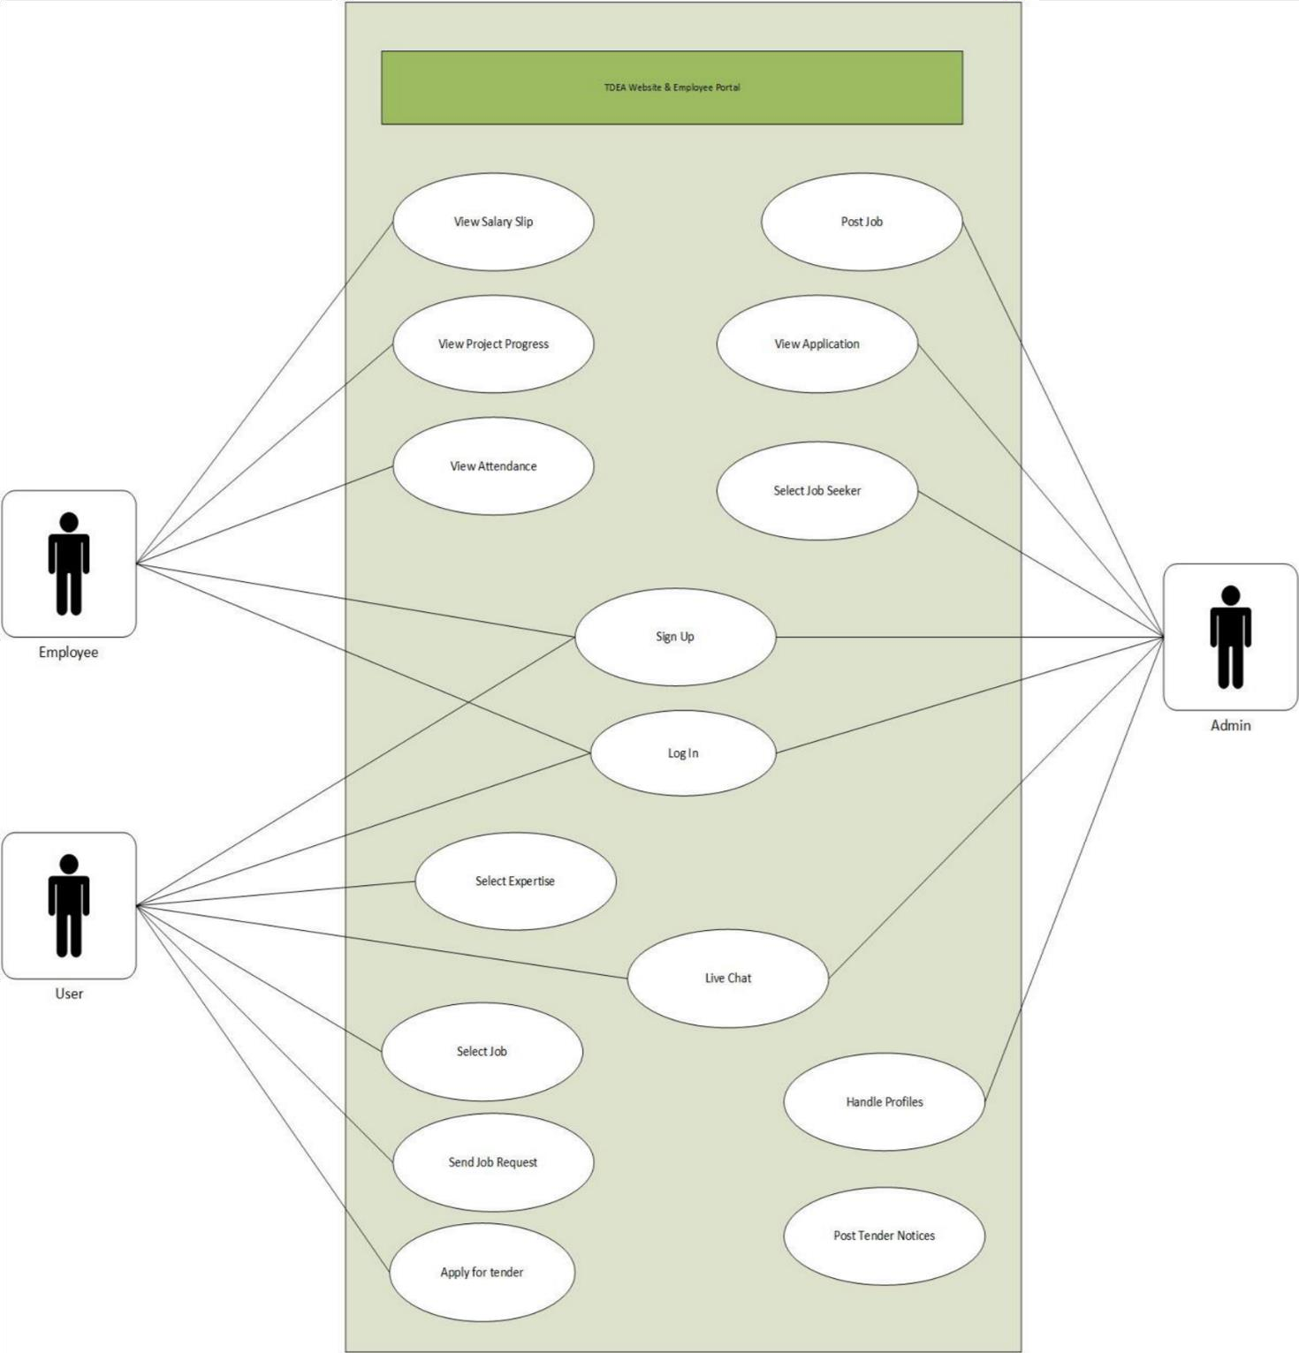

**Figure 1: *Use Case***

* + 1. **Class Diagram**

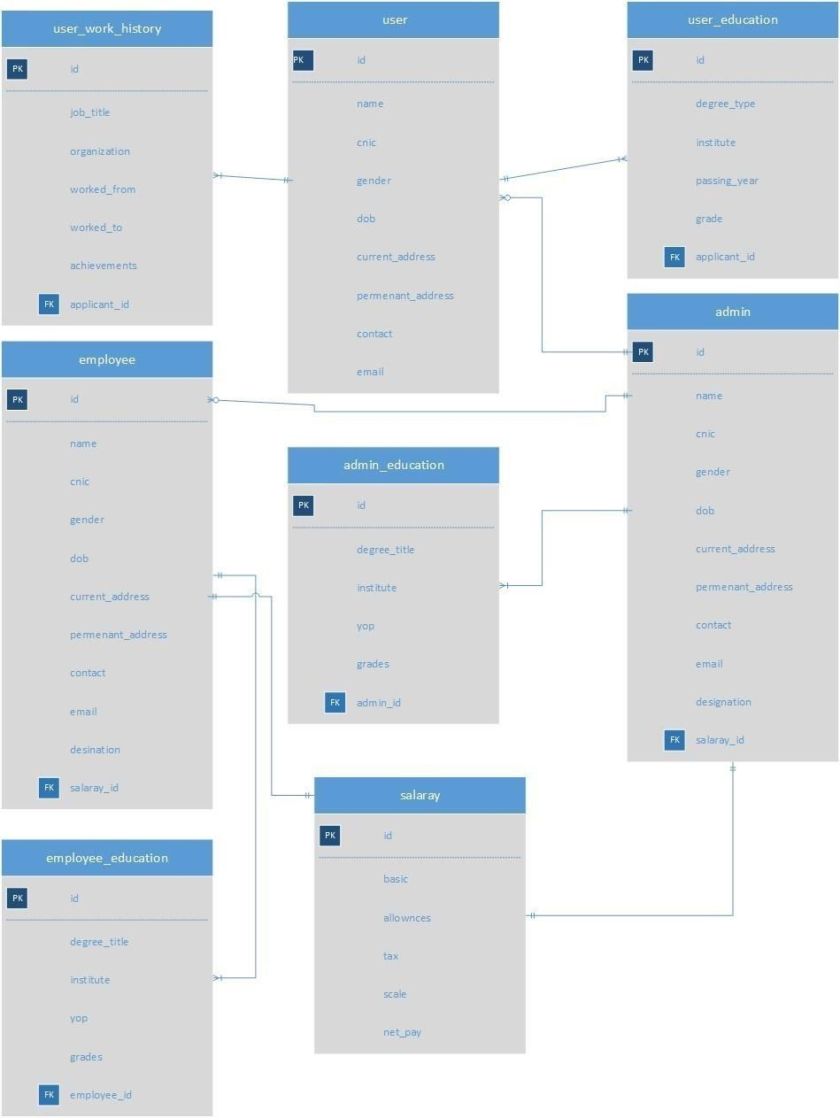

**Figure 2: *Class Diagram***

#### Activity Diagram:

The activity diagram is distributed into two parts user (job seeker) and admin (job provider).

* + - * User (Job Seeker):

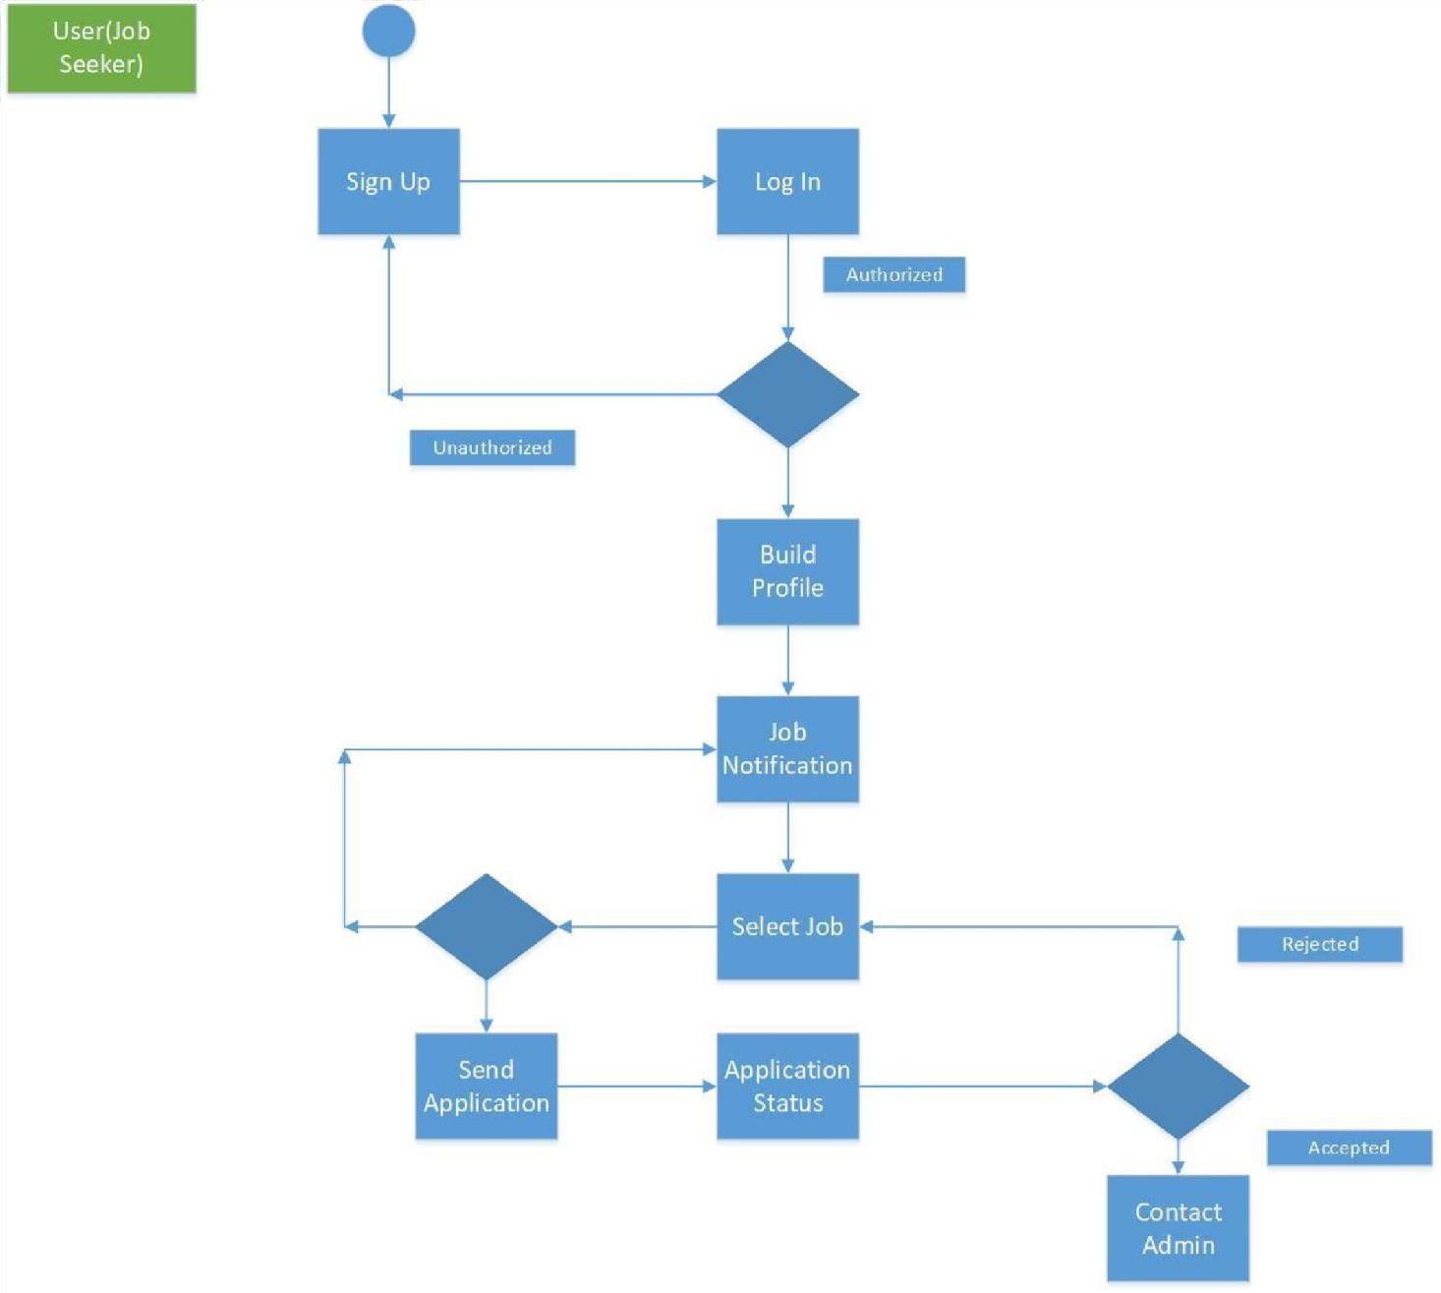

**Figure 3: *Activity Diagram (User)***

* + - * Admin(Job Provider):

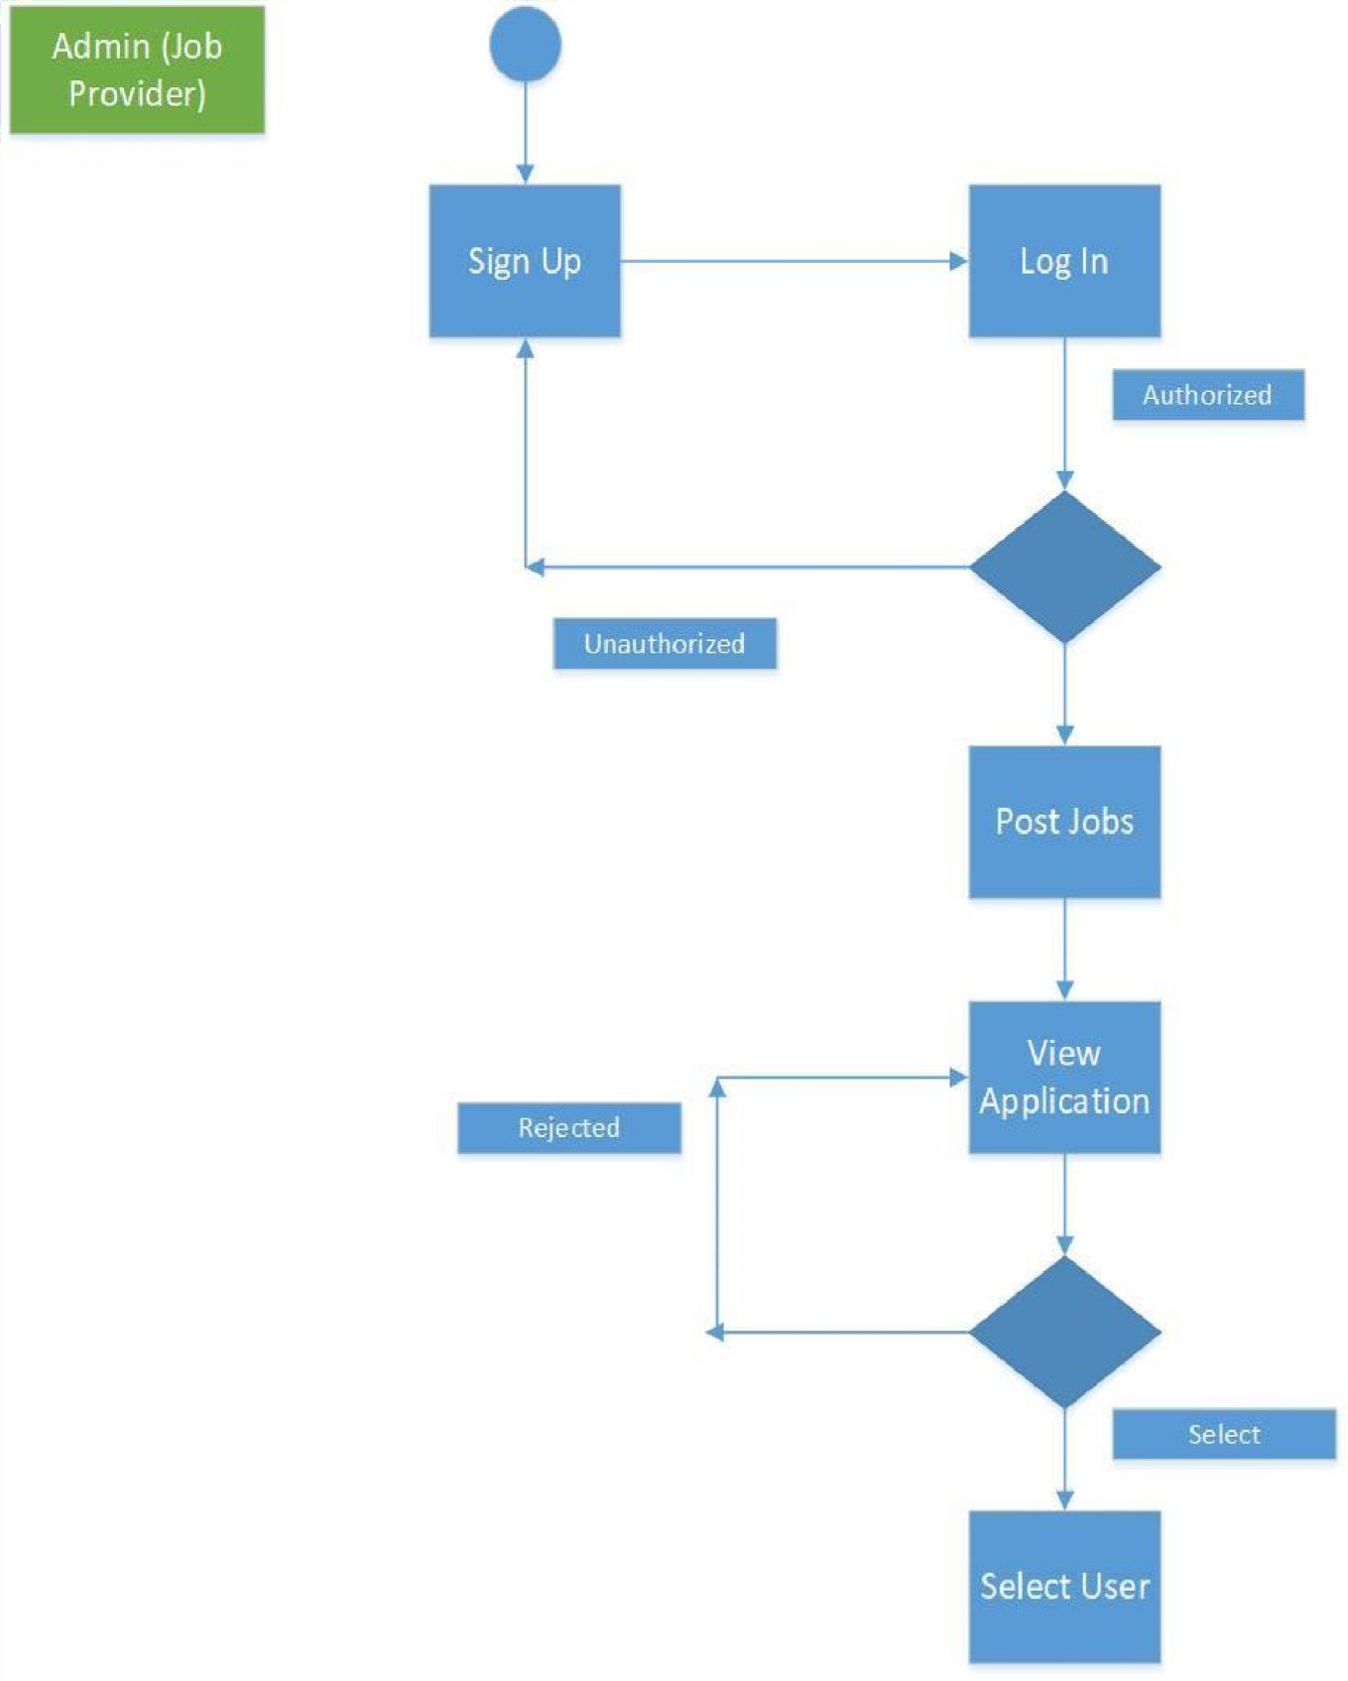

**Figure 4: *Activity Diagram (Admin)***

#### Sequence Diagram:

* + - 1. Employee Portal

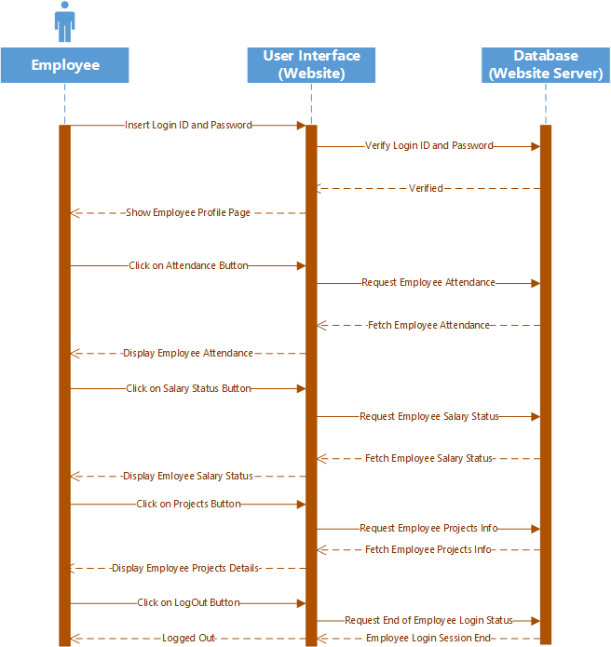

**Figure 5: *Employee Portal Sequence Diagram***

* + - 1. Admin Portal

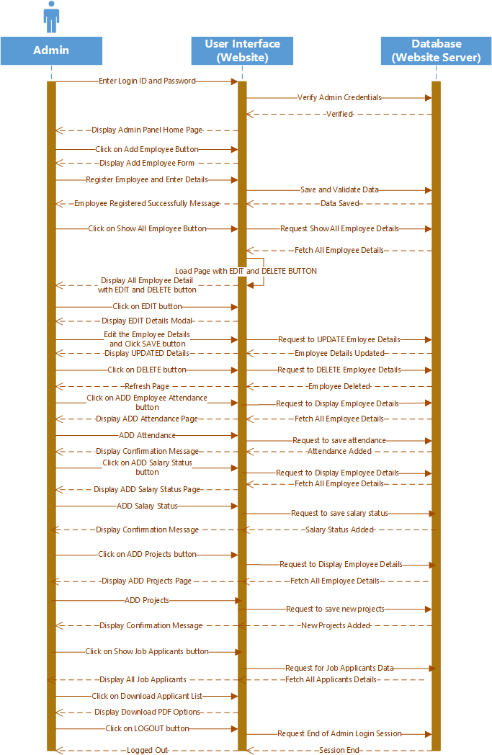

**Figure 6: *Admin Panel Sequence Diagram***

* + - 1. Online Job Portal

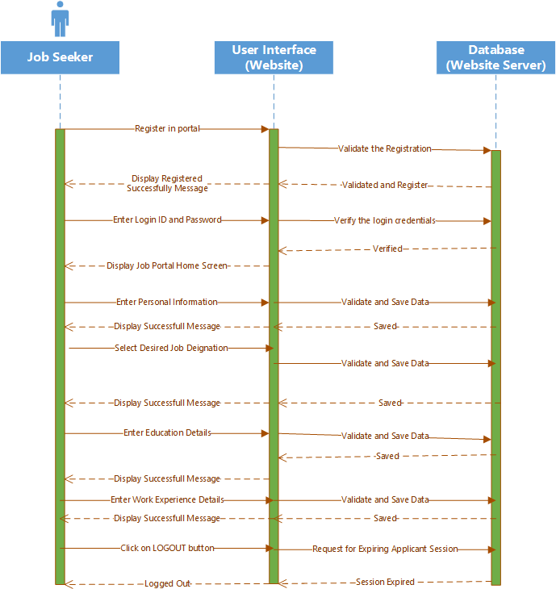

**Figure 7: *Online Job Portal Sequence Diagram***

#### Entity Relationship Diagram:

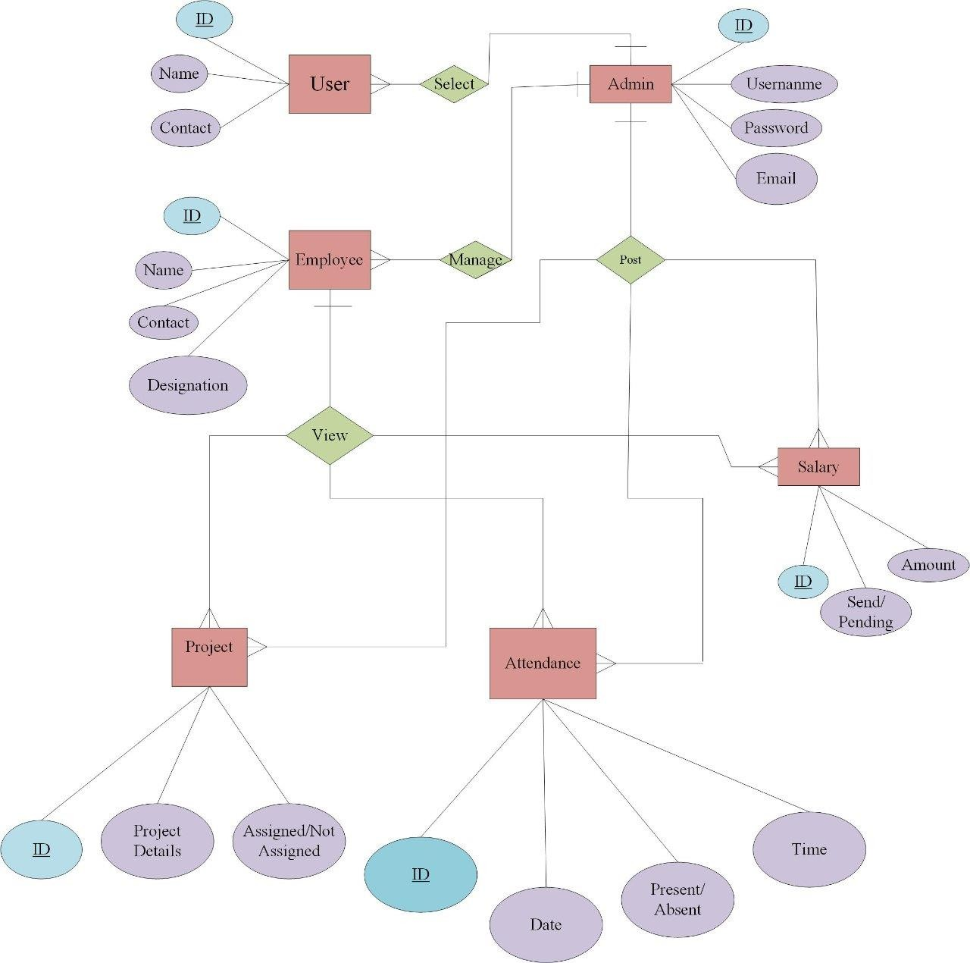

**Figure 8: *ER Diagram***

#### Preliminary Schedule:

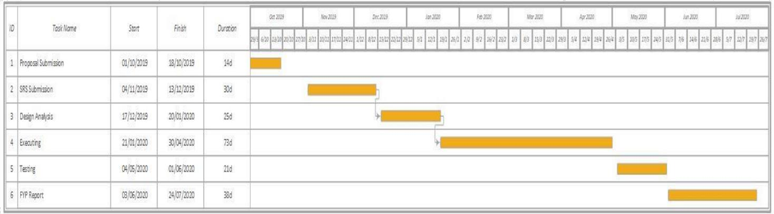

**Figure 9: *Preliminary Schedule***

#### 4.2.3.1. Preliminary Budget:

NIL

## Chapter 5 SYSTEM DESIGN

#### Designing

Designing has become one of the most compelling and attractive strategies of the web and android in the present era. Interface of the site (i.e.; input and output screen) should be easy to navigate as well as attractive so that the user cannot resist entering and visiting the specific website or application. Besides having attraction and beauty it should be simple and user-friendly so that the people having little knowledge about the internet can get benefits by easy navigations and user friendly designs. All the major segments are provided in a way that everyone can use the system efficiently. To cope with the requirements and trends of the world we have also paid our attention on the designing of our app which is very important.

#### Interface Design:

Interface design of the website is made keeping in mind the ease of user. User Interface of this system is very simple yet attractive and user can easily navigate through the website.

#### GUI:

* + 1. **Home Page:**

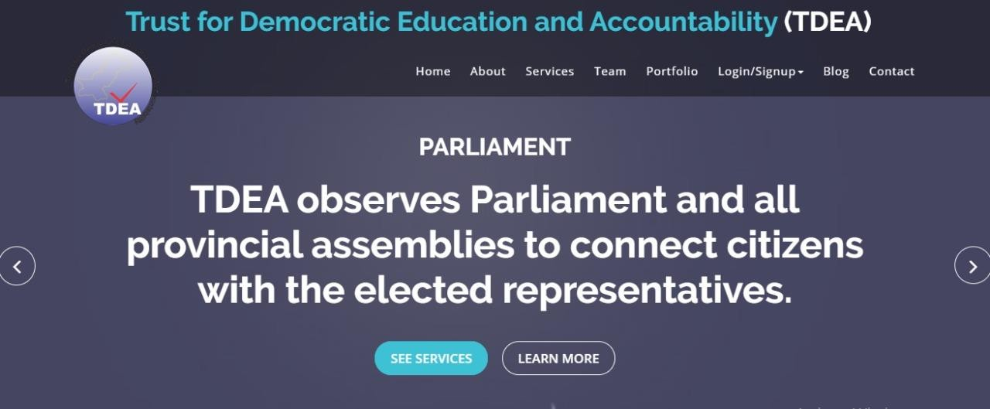

**Figure 10: *Home Page***

#### About Section:

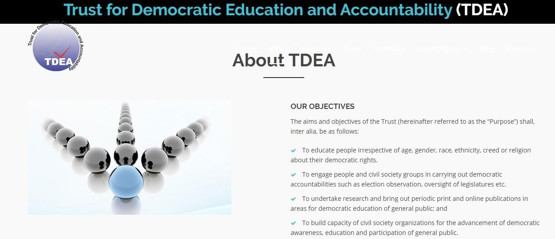

* + - 1. **About Page:**

**Figure 11: *About Section***

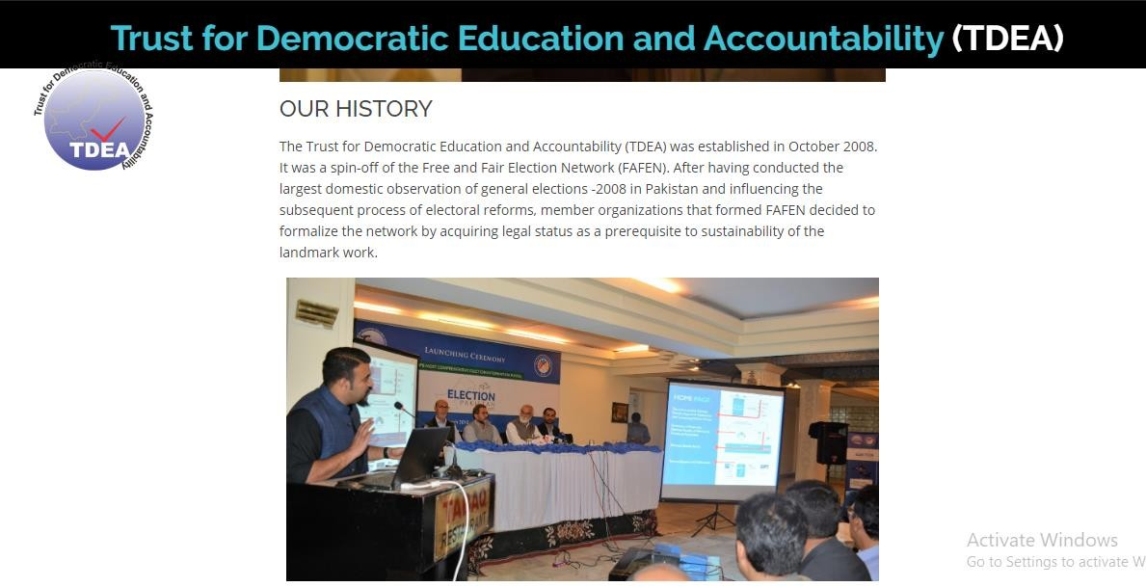

**Figure 12: *About Page***

#### Services Section:

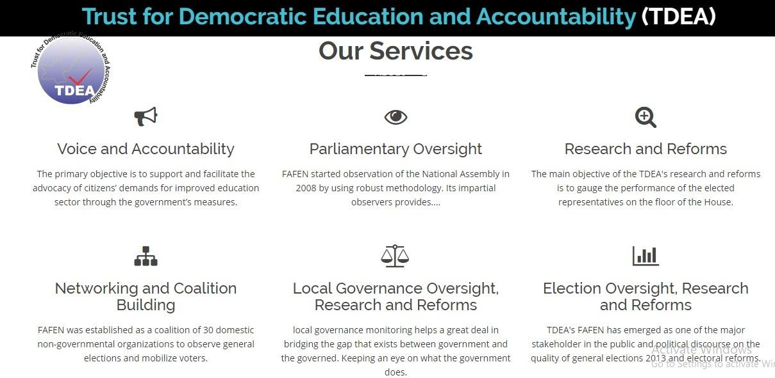

**Figure 13: *Services Section***

#### Team Lead Section:

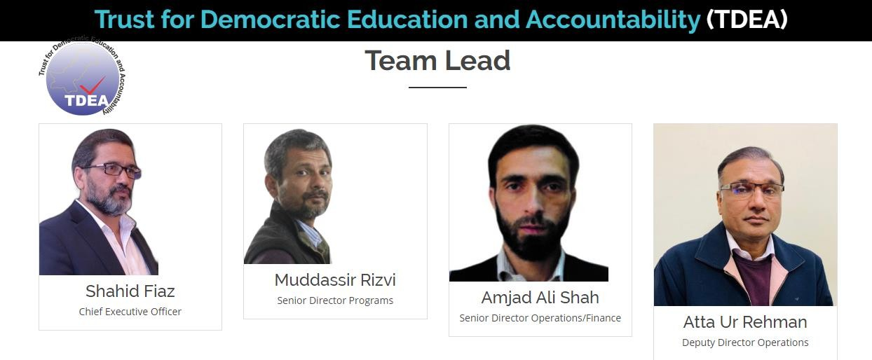

**Figure 14: *Team Lead Section***

#### Mr. Shahid Fiaz (CEO) Profile Page:

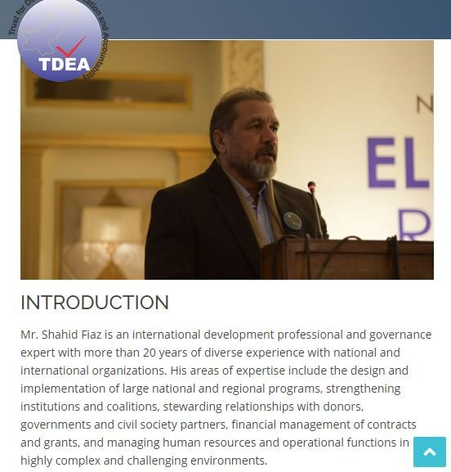

**Figure 15*: Mr. Shahid Fiaz (CEO) Profile Page***

#### Mr. Mudassir Rizvi (SDP) Profile Page:

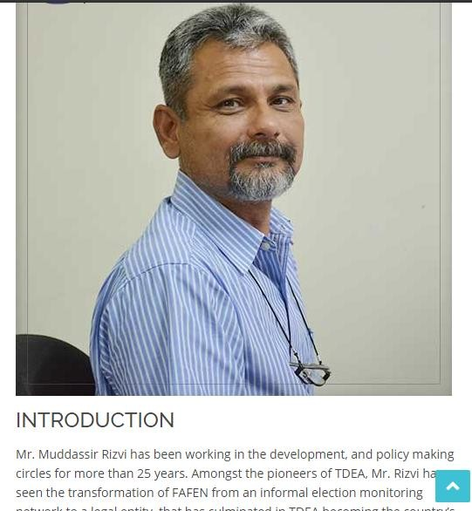

**Figure 16: *Mr. Mudassir Rizvi (SDP) Profile Page***

#### Mr. Amjad Ali Shah (SDO/F) Profile Page:

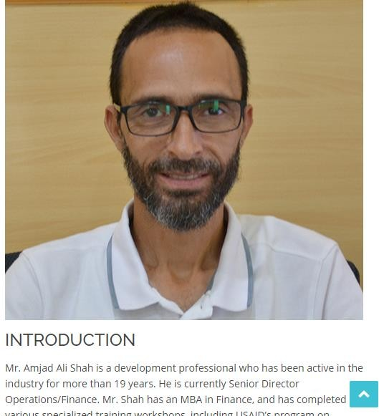

**Figure 17: *Mr. Amjad Ali Shah (SDO/F) Profile Page***

#### Mr. Atta ur Rehman (DDO) Profile Page:

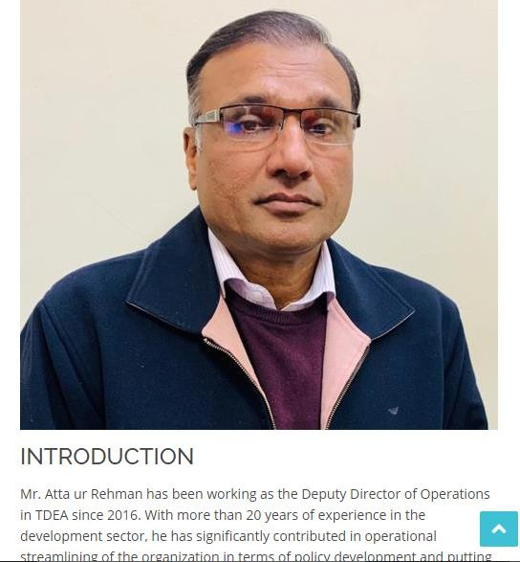

**Figure 18: *Mr. Atta ur Rehman (DDO) Profile Page***

#### Portfolio Section:

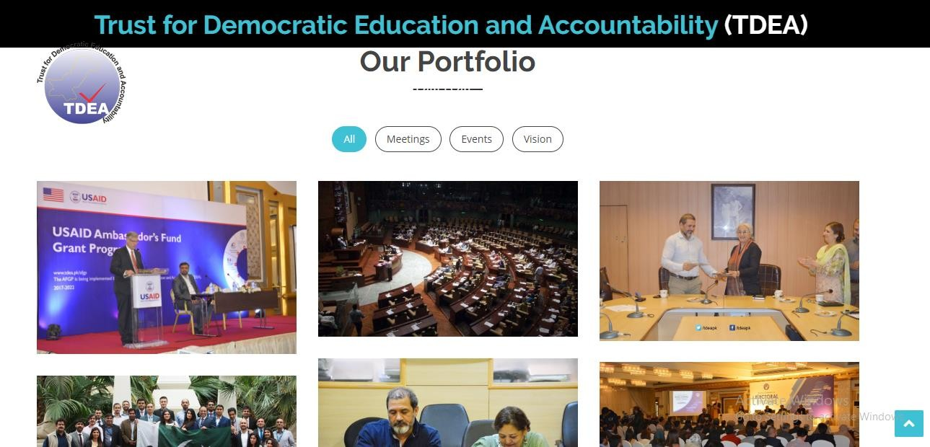

**Figure 19: *Portfolio Section***

#### Newsfeed Section:

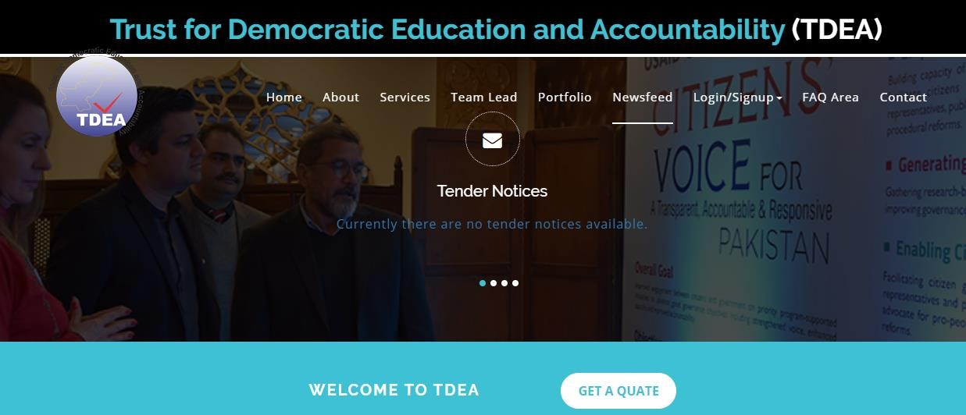

**Figure 20: *Newsfeed Section***

#### FAQ Section:

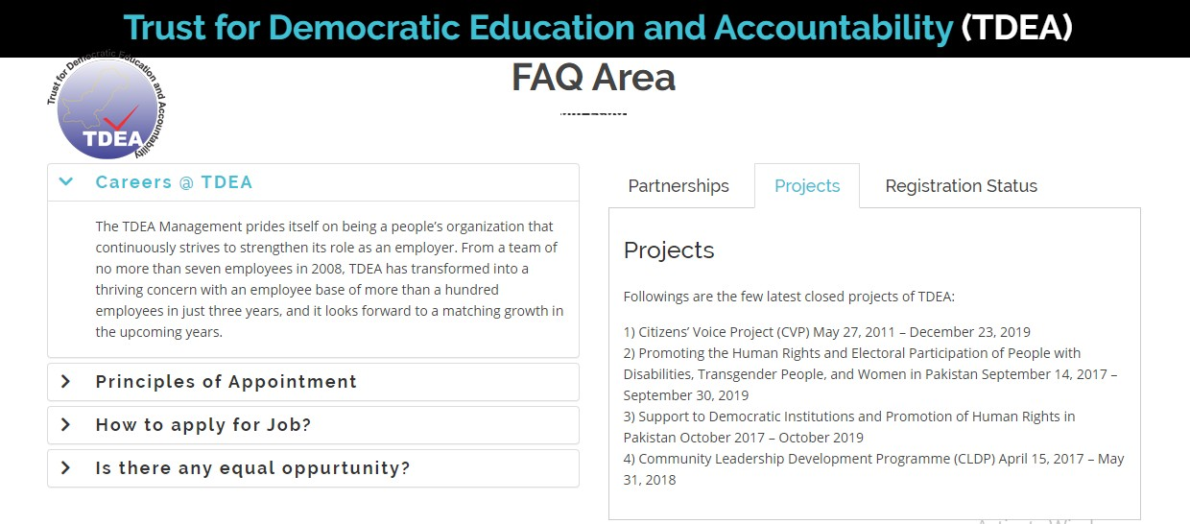

**Figure 21: *FAQ Section***

#### Contact Us Section:

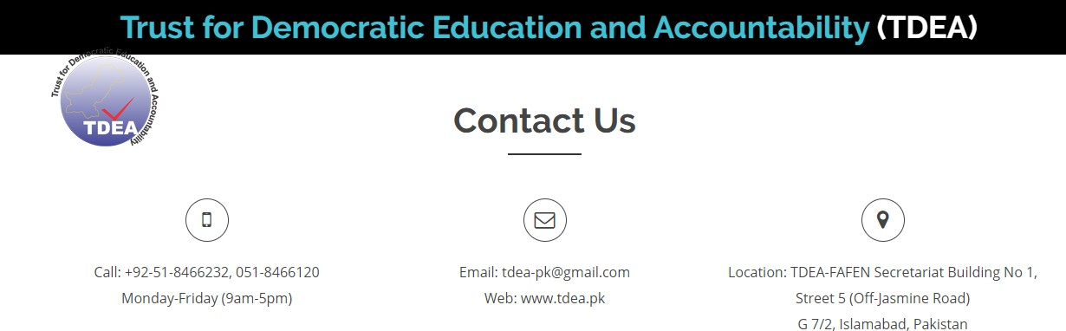

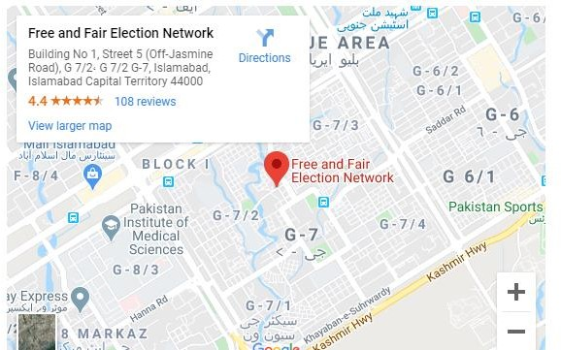

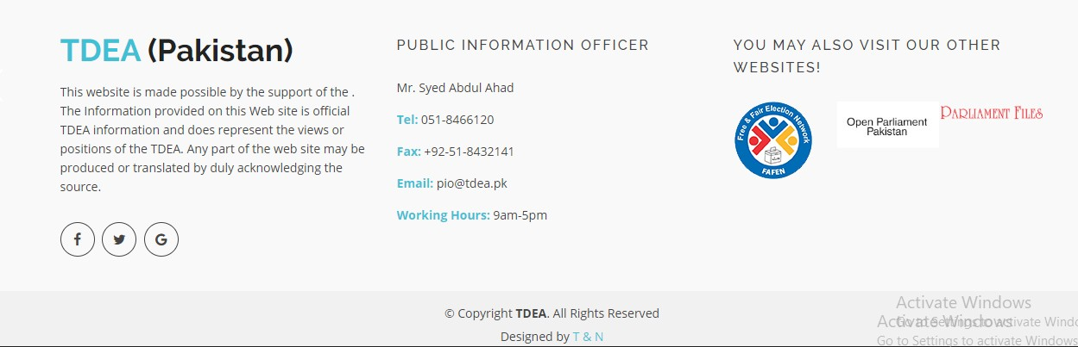

**Figure 22: *Contact Us Section***

#### Job Portal:

* + - 1. **Login Page:**

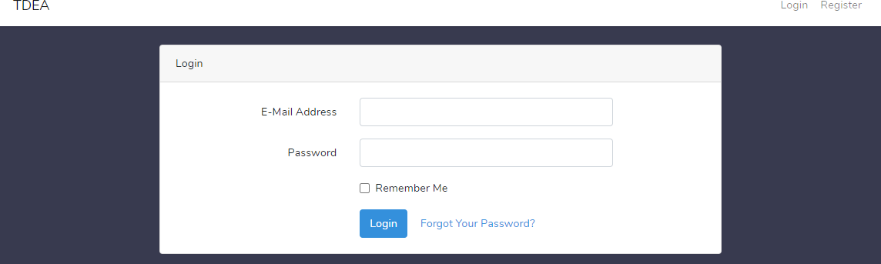

**Figure 23: *Job Portal Login Page***

#### Registration Page:

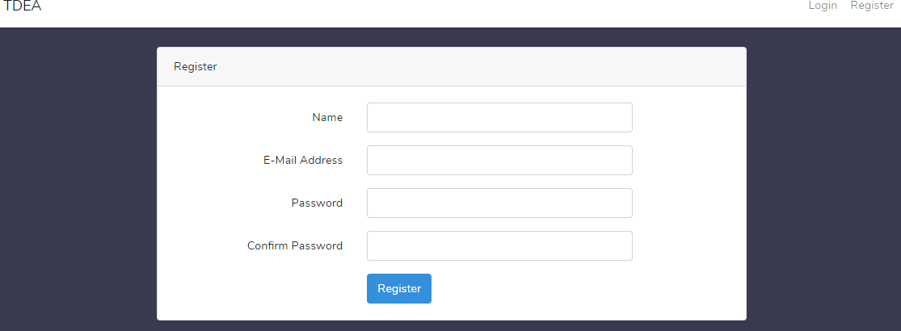

**Figure 24: *Job Portal Registration Page***

#### Personal Information Section:

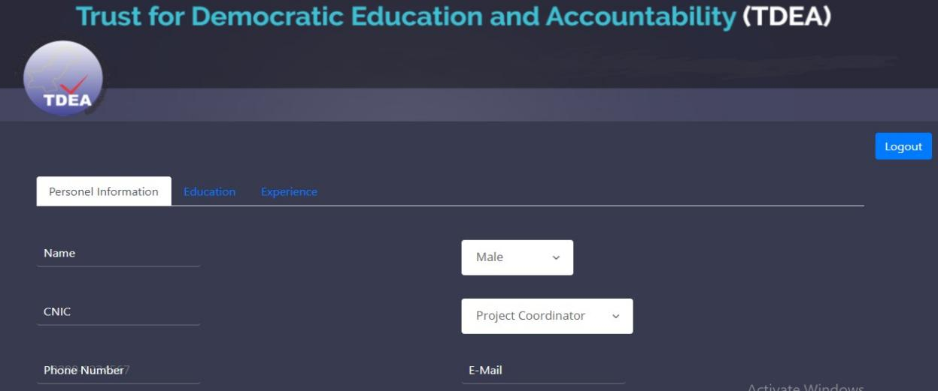

**Figure 25: *Job Portal Personal Info Section***

#### Education Section:

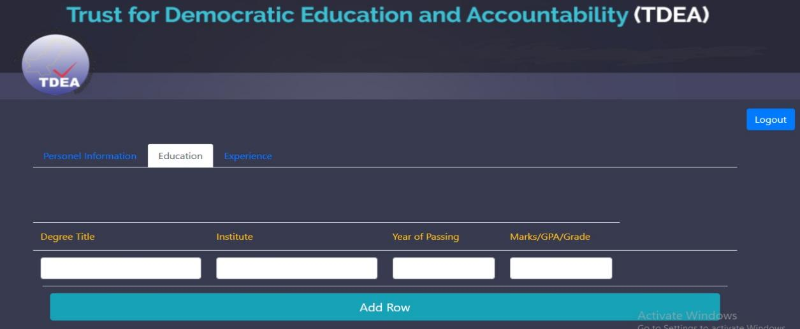

**Figure 26: *Job Portal Education Section***

#### Experience Section:

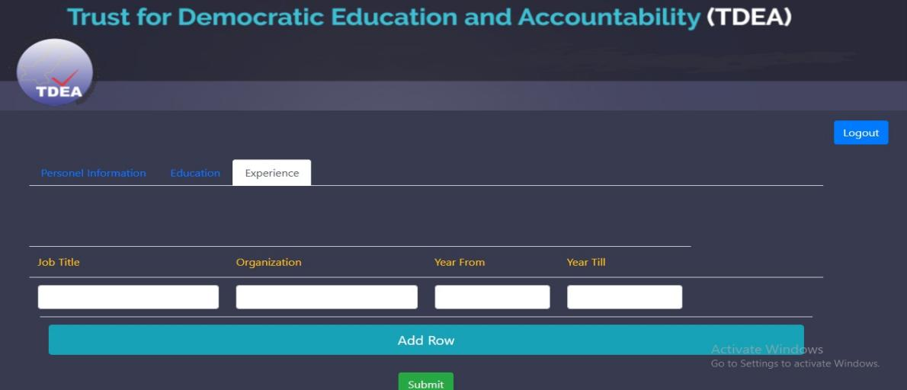

**Figure 27: *Job Portal Experience Section***

#### Employee Portal Page:

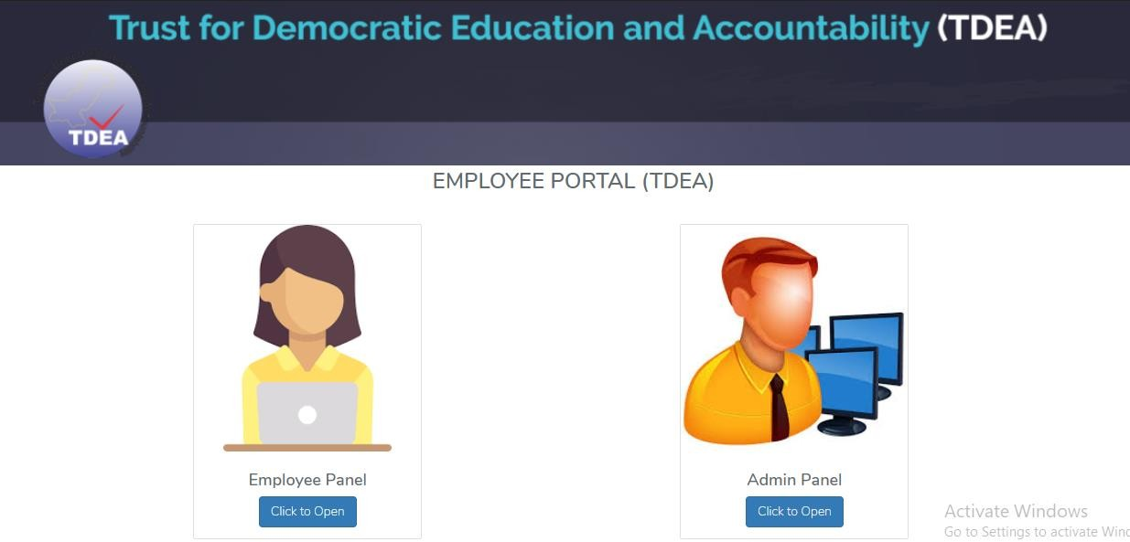

**Figure 28: *Employee Portal Page***

#### Employee Panel:

* + - * 1. **Login Page:**

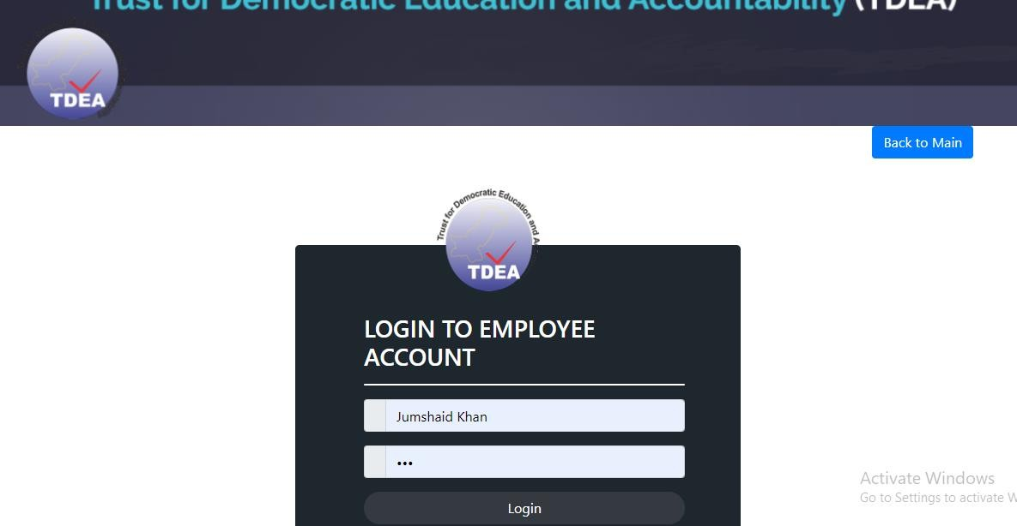

**Figure 29: *Employee Panel Login Page***

#### Employee Home Page:

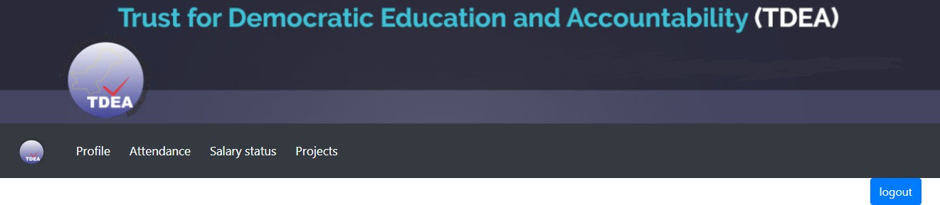

**Figure 30: *Employee Panel Home Page***

#### Employee Profile Page:

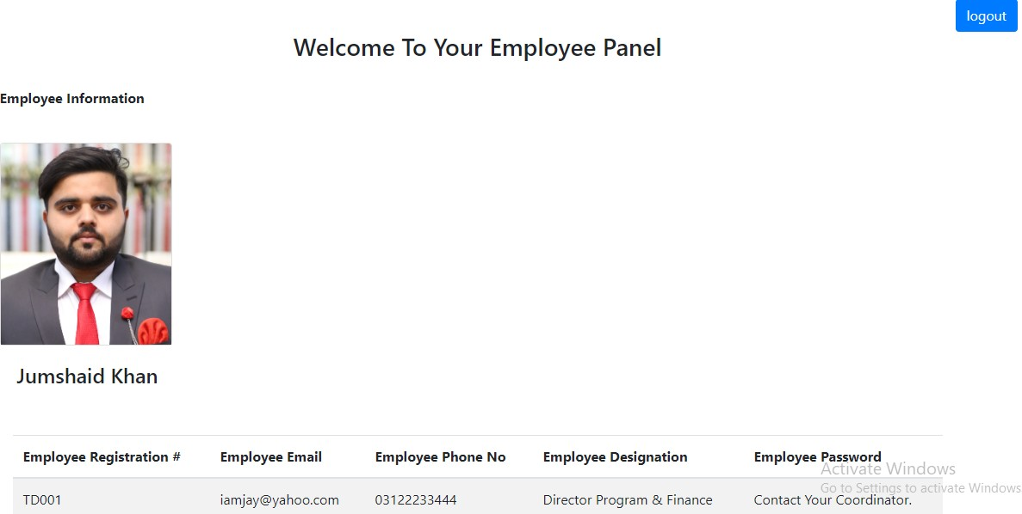

**Figure 31: *Employee Profile Page***

#### Employee Attendance Page:

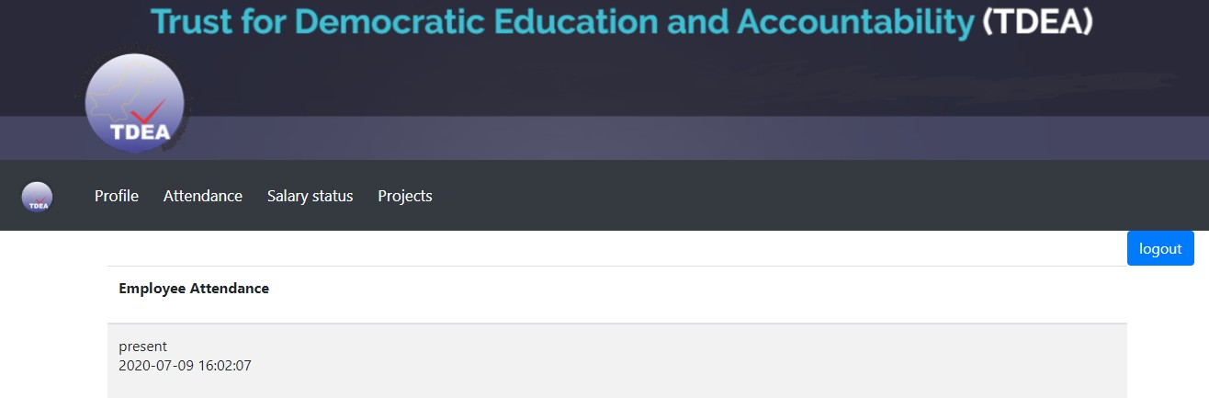

**Figure 32: *Employee Attendance Page***

#### Employee Salary Page:

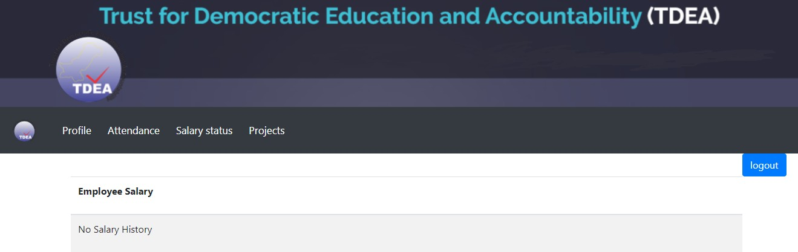

**Figure 33: *Employee Salary Page***

#### Employee Project Page:

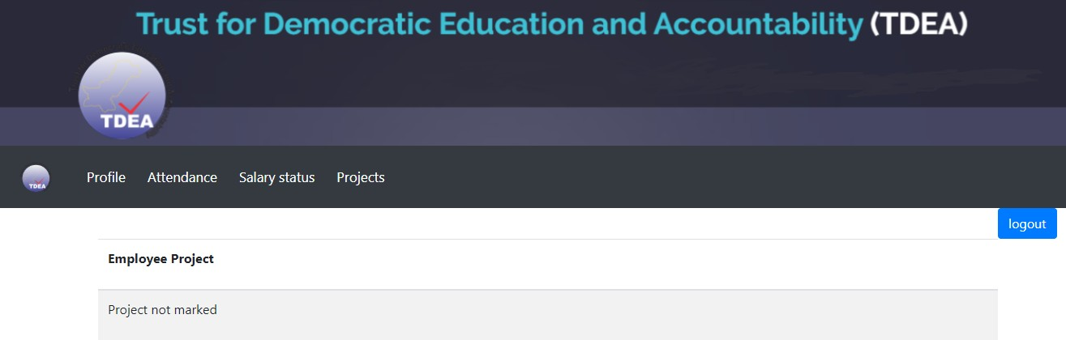

**Figure 34: *Employee Project Page***

#### Admin Panel:

* + - * 1. **Login Page:**

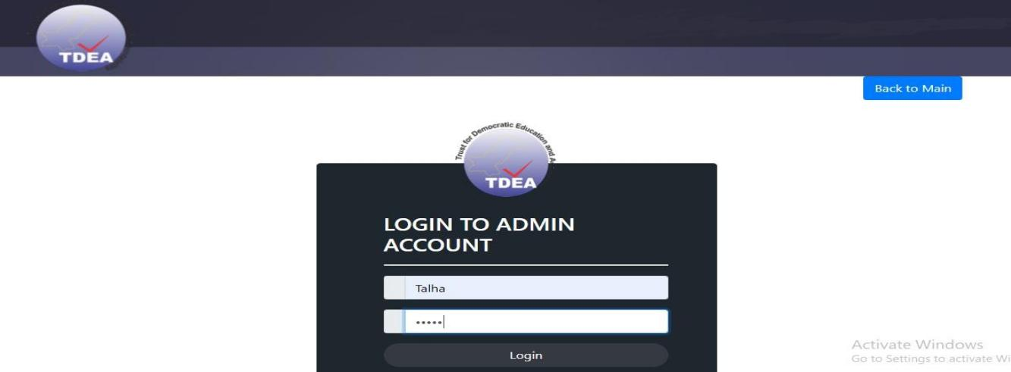

**Figure 35: *Admin Panel Login Page***

#### Admin Home Page:

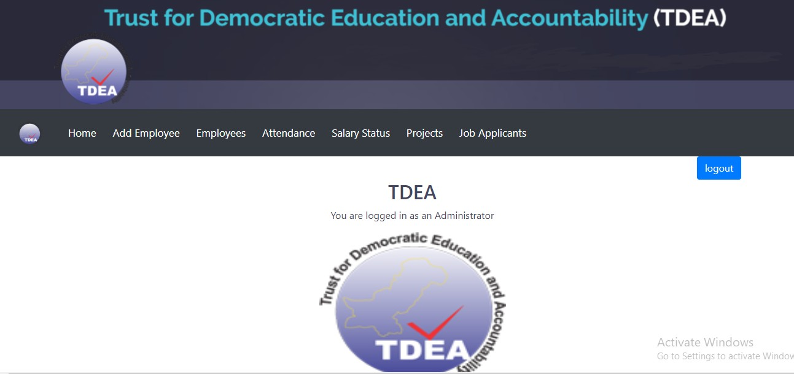

**Figure 36: *Admin Home Page***

#### Add Employee Page:

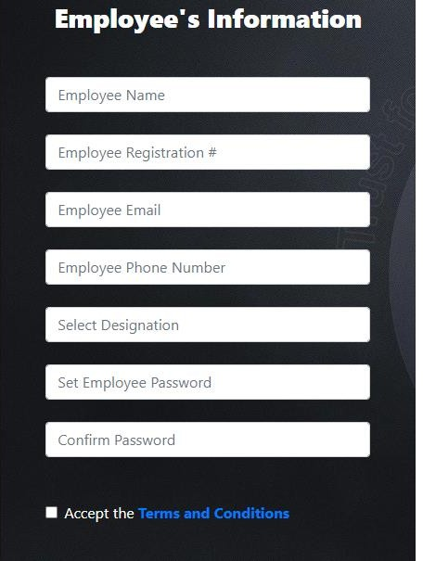

**Figure 37: *Add Employee Page***

#### Employee Page:

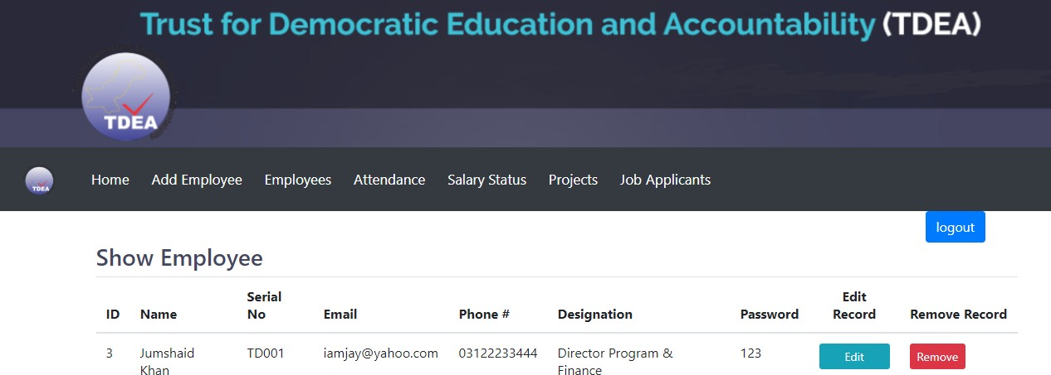

**Figure 38: *Employee Page***

#### Edit Employee Details Page:

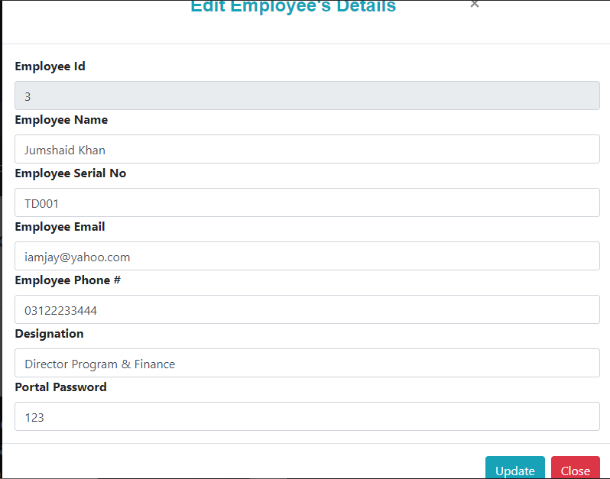

**Figure 39: *Edit Employee Details Page***

#### Add Employee Attendance Page:

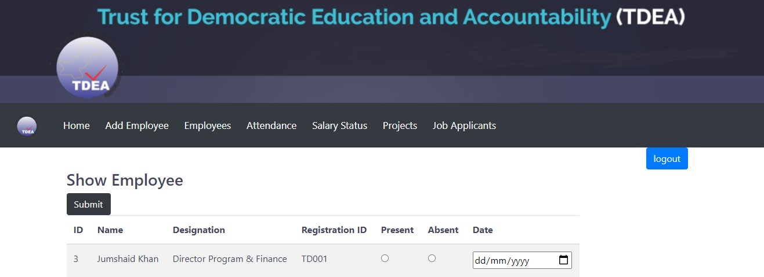

**Figure 40: *Add Employee Attendance Page***

#### Add Employee Salary Status Page:

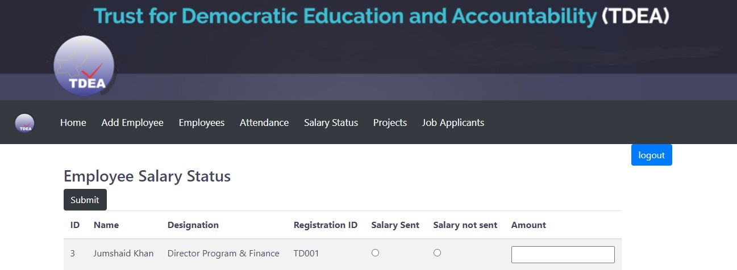

**Figure 41: *Add Employee Salary Status Page***

#### Add Employee Projects Page:

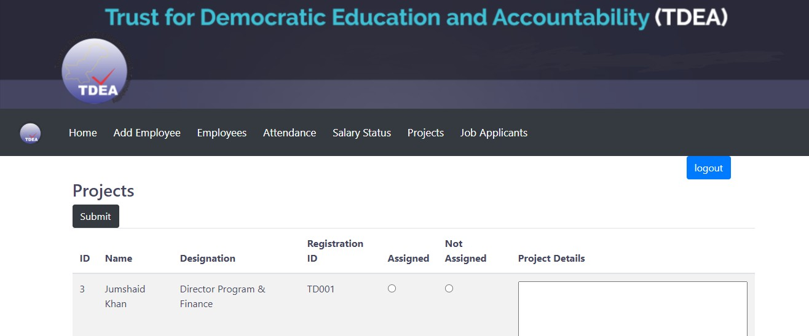

**Figure 42: *Add Employee Projects Page***

#### Show Job Applicants Page:

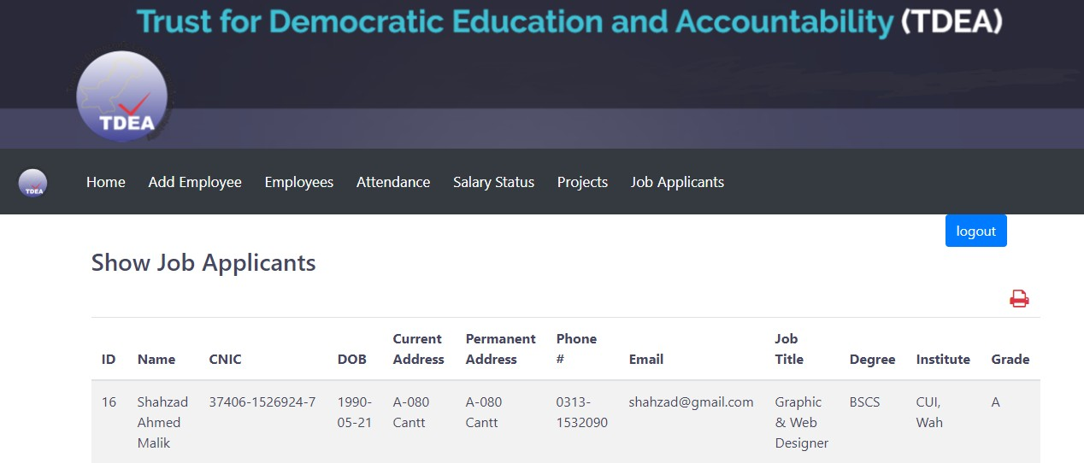

**Figure 43: *Show Job Applicants Page***

#### Print Job Applicants List Page:

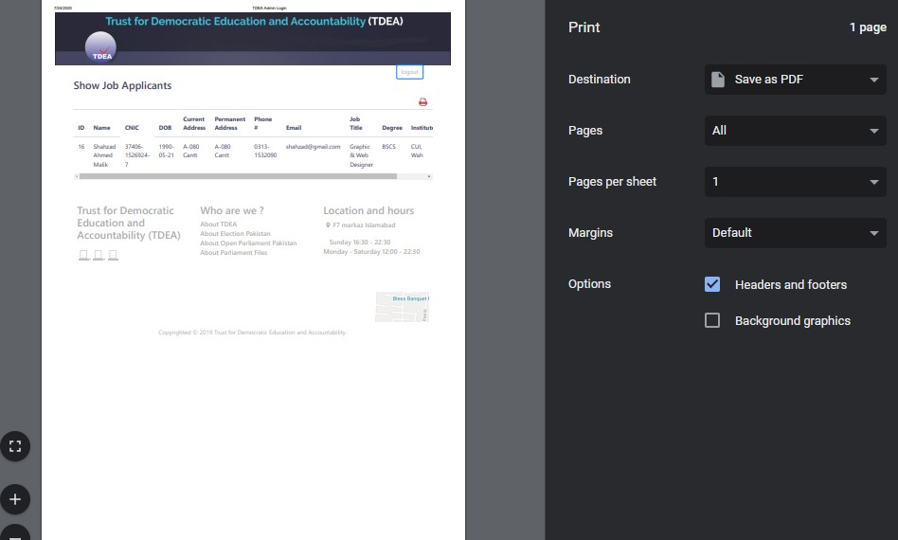

**Figure 44: *Print Job Applicants List Page***

#### 5.3.10.3.0. Database:

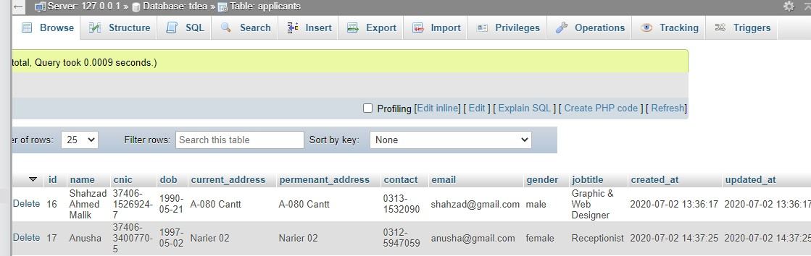

**Figure 45: *Database***

#### Live Chat:

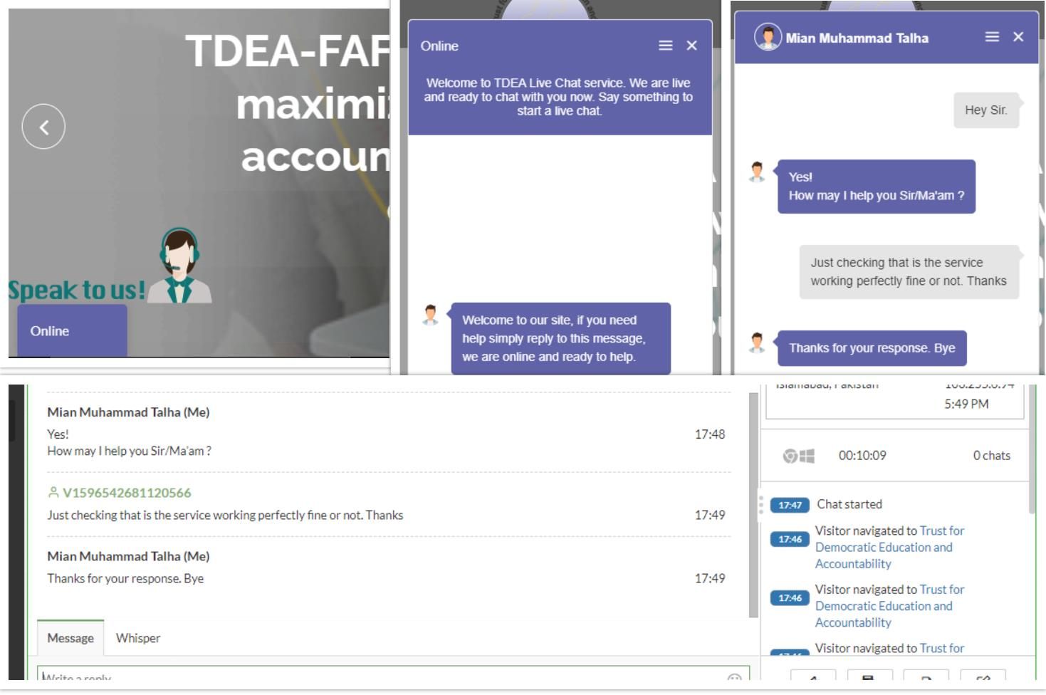

**Figure 46: *Live Chat Screens***

#### Interface Specifications:

* + 1. **User Interface:**

User participation is very important at every stage of development process, particularly for the design of the user interface. That is why we crafted this project to make it easier for user to use it and navigate through it.

#### GUI:

Various graphical user interfaces of our project are:

* + - * Job seeker can login/signup on the website to apply for jobs online.
      * Admin can login/signup to upload jobs and maintain employee data.

#### Code Design:

We are using Laravel to design the interface of web application. We are also using XAMPP server for local database server and also for the testing purposes.

#### Software Interfaces:

1. Laravel Framework
2. HTML, CSS, Bootstrap, JS
3. AJAX
4. PHP
5. My SQL (for database)

#### User Friendly:

The users of the current setup will not face any problem in handling the website having simple understanding buttons to perform functionality. The new elegant system will be completely menu driven and provide help to the users. Only basic knowledge about the web is required to handle and use this system.

#### Design Constraints:

Our system shall conform to the following Design constraints: The system should be built by using a standard web development tool.

#### Standards Compliance:

Our website follows the existing standards and regulations of working.

#### Hardware Limitations:

Our website supports Android Phones and Android Tablets.

## Chapter 6 QUALITY ASSURANCE

#### Introduction:

In quality assurance phase which is mainly based on Test plan including testing strategies and types of testing applied to ensure the reliability, security and accuracy of the system to give the user a great and error free learning experience. Happiness and satisfaction of customer (User) is our first and foremost priority to ensure that a proper testing mechanism was devised and the results are tabulated in the form of test cases and to trace each test case against desired functional requirement. A requirement traceability matrix has been devised which include test case name and id against each and every functional requirement desired by user.

* 1. **Testing Levels**

The system testing can be performed at different levels. Following are the different software testing level.

* + - Unit Testing
    - Integration Testing
    - System Testing

### Testing plane

#### Black Box Testing

Black Box Testing known as Behavioral Testing because it tests the functional requirements of the software and hardware. It enables the system to attain a set of input which will fully activate all practical (Functional) of a program. It is not a replacement of the white box testing technique. Relatively, it is a compatible procedure that probably exposes a various class of flaws than white box methods.

Black box testing seeks to observe/find errors in the following categories:

##### Inaccurate or misplaced (incorrect and missing) function

* + - * **Interface flaws**
      * **Coding error**

#### White Box Testing

In this testing we have inspected the inner data composition, algorithms and the implemented code of the system.

### Test Cases:

##### Definition.

A test case is a specification of the inputs, execution conditions, testing procedure, and expected results that define a single test to be executed to achieve a particular software testing objective, such as to exercise a particular program path or to verify compliance with a specific requirement.

* + 1. **Test Case 1:**

|  |  |
| --- | --- |
| Test Name | To check verification of job portal login page |
| Screen to be tested | Job Portal Log In screen |
| Input | Wrong Id and Password |
| Output | Verify provided data |
| Expected Result | Login to Job Portal system |
| Actual Result | In this test the agent was tested if he provides wrong ID or wrong password the system didn’t allow him/her logged into the profile and to enter in the dashboard. But when  valid data was entered then the system will provided its functionality to be performed by the agent. |

**Table 9: *Test Case 1***

#### Test Case 2:

|  |  |
| --- | --- |
| Test Name | To check validity of Name, Phone#, CNIC Format |
| Screen to be tested | Job Portal  Information stored only if applicant follow the format. If wrong validation or format enter it generate errors. |
| Expected Result |
| Actual Result |

**Table 10: *Test Case 2***

#### Test Case 3:

|  |  |
| --- | --- |
| Test Name | Job Application Submission to Database |
| Function to be tested | Data entry in database |
| Input | Add information by applicant and click submit button. |
| Output | Your application has been submitted successfully. |
| Expected Result | If applicant follow the correct way to enter information and click on submit, then data should be submit in database |
| Actual Result | Your application has been submitted successfully. |

**Table 11: *Test Case 3***

#### Test Case 4:

|  |  |
| --- | --- |
| Test Name | To check verification of Employee login page |
| Screen to be tested | Employee Panel Log In screen |
| Input | Wrong Id and Password |
| Output | Verify provided data |
| Expected Result | Login to Employee Panel system |
| Actual Result | In this test the agent was tested if he provides wrong ID or wrong password the system didn’t allow him/her logged into the profile and to enter in the dashboard. But when valid data was entered then the system will provided its functionality to be performed by the agent. |

* + 1. **Test Case 5:**

**Table 12: *Test Case 4***

|  |  |
| --- | --- |
| Test Name | Employee Registration |
| Function to be tested | Add Employee |
| Expected Result | Only First admin can create new employee accounts |
| Actual Result | First Admin can register the other employees. |

**Table 13: *Test Case 5***

## Chapter 7 Conclusion

#### 7.1 Conclusion

We are thankful to ALLAH ALMIGHTY who has given us the courage to fulfill our task. This projection is quite enjoyable as we have been given the opportunity to manage a project from start to finish. It was due to this project that we came to know how a professional software is designed.

We have worked on everything we have proposed in the proposal to make an efficient and better website which will help the administration and employees to organize their tasks and it will help job seekers to easily apply for jobs online.

# Appendix A

The appendix A lists all the references.

### References

Following are the references.

**[1].** https://stackoverflow.com/questions/12254479/sqlite-creating-uploading-and- managing-an-online-database

**[2][.](https://youtube.com/)** [https://youtube.com](https://youtube.com/)

**[3][.](https://github.compdfs.semanticscholar.org/f097/7bd89eed67e631f83eacda3a546ecc2b6c8b.pdf)** [https://github.com](https://github.compdfs.semanticscholar.org/f097/7bd89eed67e631f83eacda3a546ecc2b6c8b.pdf)

**[4][.](https://stackoverflow.com/)** [https://stackoverflow.com](https://stackoverflow.com/)

**[5][.](https://laravel.com/)** <https://laravel.com/>

**[6][.](https://laracasts.com/series/laravel-from-scratch-2018)** <https://laracasts.com/series/laravel-from-scratch-2018>

**[7][.](https://www.w3schools.com/)** <https://www.w3schools.com/>

**[8][.](https://www.w3schools.com/)** [https://tdea.pk/](https://www.w3schools.com/)

**[9][.](https://www.heroku.com/)**<https://www.heroku.com/>

**[10][.](https://www.tawk.to/)**<https://www.tawk.to/>

**[11].**<https://www.youtube.com/watch?v=0O5QB6Hvcck>